Caledonian Mining Cables

AS/NZS 1972:2006 Cables

Type 1 1.1/1.1KV Individually Screened

» Applications .............................................................................................................

These individually copper screened cables are used for wiring of machines, or between machines and equipment where PVC is suitable.

» Standards .................................................................................................................

AS/NZS 1972:2006
AS/NZS 1125
AS/NZS 3808

» Construction ............................................................................................................

Conductors: Stranded copper conductor.

Insulation: PVC.

Individual Composite Screen (earth conductor): Tinned annealed copper braiding interwove with polyester yarn.

Binding: Polyester tape.

Sheath: PVC sheath.

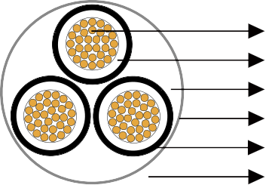
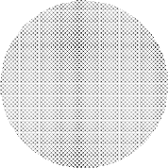
Stranded Tinned Copper Conductor PVC Insulation
Filler

Polyester Tape

Individual Composite Screen PVC Sheath




» Dimensions and Weight ..........................................................................................

Number of Cores | Nominal Conductor Area | Strand Size | Insulation Thickness | Core Screen |  | Thickness of Sheath | Nominal Overall Diameter | Nominal Weight
 |  |  |  | Strand Size | Area of  Screen | Thickness of Sheath | Nominal Overall Diameter | Nominal Weight
 | mm² | No/mm | mm | mm | mm² | mm | mm | kg/100m
Type 1 - Individually Screened
3 | 1.5 | 30/0.25 | 0.8 | 0.20 | 3.5 | 0.8 | 10.1 | 16
4 | 1.5 | 30/0.25 | 0.8 | 0.20 | 4.6 | 0.8 | 11.1 | 21
3 | 10 | 77/0.40 | 1.0 | 0.20 | 6.8 | 1.0 | 18.6 | 59
4 | 10 | 77/0.40 | 1.0 | 0.20 | 9.0 | 1.0 | 20.5 | 75
3 | 16 | 126/0.40 | 1.0 | 0.20 | 7.9 | 1.3 | 21.6 | 84
4 | 16 | 126/0.40 | 1.0 | 0.20 | 10.6 | 1.3 | 23.7 | 110

44 www.caledonian-cables.co.uk www.addison-cables.com

