Caledonian Mining Cables

AS/NZS 1972:2006 Cables

Type 2S 1.1/1.1KV & 3.3/3.3KV Collectively Screened

» Applications .............................................................................................................

These collectively copper screened cables are used for wiring of machines or between machines and equipment where a rubber cable is desired. These cables are also used for longwall lighting circuits, and may contain pilot and control cores or twisted pair and screened cores.

» Standards .................................................................................................................

AS/NZS 1972:2006
AS/NZS 1125
AS/NZS 3808

» Construction ............................................................................................................

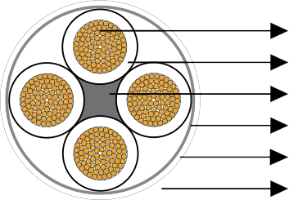

Conductors: Stranded tinned annealed copper conductor.

Insulation: EPR.

Filling: Elastomer centre filler.

Bedding: Polyester tape.

Stranded Tinned Copper Conductor EPR Insulation
Elastomer Centre Filler Polyester Tape Composite Screen Heavy Duty CPE Sheath



Composite Screen (earth conductor): Tinned annealed copper braiding interwove with polyester yarn.

Sheath: Heavy duty CPE sheath.

» Dimensions and Weight ..........................................................................................

Number of Core | Nominal Conductor Area | Strand Size | Insulation Thickness | Core Screen |  | Nominal Sheath Thickness | Nominal Overall Diameter | Nominal Weight
 |  |  |  | Strand Size | Area of  Screen | Nominal Sheath Thickness | Nominal Overall Diameter | Nominal Weight
 | mm² | No/mm | mm | mm | mm² | mm | mm | kg/100m
Type 2S 1.1/1kV Collectively Screened
2 | 1.5 | 30/0.25 | 1.0 | 0.20 | 5.3 | 1.8 | 14.7 | 17
4 | 1.5 | 30/0.25 | 1.0 | 0.20 | 12.1 | 1.8 | 19.9 | 26
6 | 1.5 | 30/0.25 | 1.0 | 0.20 | 22.6 | 1.8 | 25.7 | 35
16 | 1.5 | 30/0.25 | 1.0 | 0.25 | 113.1 | 1.8 | 47.1 | 71
20 | 1.5 | 30/0.25 | 1.0 | 0.25 | 159.0 | 1.8 | 53.2 | 82

48 www.caledonian-cables.co.uk www.addison-cables.com

