

Caledonian Mining Cables

AS/NZS 1972:2006 Cables

Type A & B 1.1/1.1KV

» Applications .............................................................................................................

These cables are used as 1.1kV cables to distribute power within the mine, suitable for use in underground coal mines. For Type A cables, optional 3 pilots can be selected.

» Standards .................................................................................................................

AS/NZS 1972:2006
AS/NZS 1125
AS/NZS 3808

» Construction ............................................................................................................
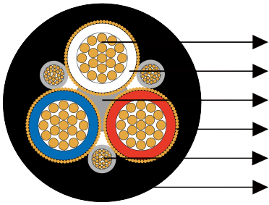

Stranded Tinned Copper Conductor EPR Insulation
Elastomer Centre Filler Copper Wire Screen Optional Pilot Core Heavy Duty PCP Sheath

Conductors: Stranded tinned annealed copper conductor.

Insulation: EPR.

Filling: Elastomer centre filler.

Optional Pilot Core (Type A only): CPE composite insulated and covered pilot conductor.

Screen (earth conductor): Copper wire.

Sheath: Heavy duty PCP sheath.

www.caledonian-cables.co.uk www.addison-cables.com 49



Caledonian Mining Cables
AS/NZS 1972:2006 Cables

» Dimensions and Weight ..........................................................................................

Nominal Conductor Area | Strand Size | Insulation Thickness | Core Screen |  | Pilot Conductor |  |  | Nominal Sheath Thickness | Nominal Overall Diameter | Nominal Weight
Nominal Conductor Area | Strand Size | Insulation Thickness | Strand Size | Area of Screen |  | Strand Size | Thickness of Covering | Nominal Sheath Thickness | Nominal Overall Diameter | Nominal Weight
mm² | No/mm | mm | mm | mm² |  | No/mm | mm | mm | mm | kg/100m
Type A & B
16 | 7/1.70 | 1.4 | 48/0.40 | 6.0 |  | 24/0.20 | 1.6 | 2.5 | 24.6 | 120
25 | 19/1.35 | 1.4 | 57/0.40 | 7.2 |  | 32/0.20 | 1.8 | 2.5 | 28.0 | 170
35 | 19/1.53 | 1.5 | 63/0.40 | 7.9 |  | 30/0.25 | 1.8 | 2.5 | 30.4 | 205
50 | 19/1.78 | 1.7 | 72/0.40 | 9.0 |  | 50/0.25 | 2.0 | 3.0 | 34.9 | 270
70 | 19/2.14 | 1.8 | 67/0.50 | 13.2 |  | 80/0.25 | 2.0 | 3.3 | 40.2 | 370
95 | 19/2.52 | 2.0 | 77/0.50 | 15.1 |  | 80/0.25 | 2.0 | 3.8 | 46.1 | 490
120 | 37/2.03 | 2.2 | 65/0.67 | 22.9 |  | 80/0.25 | 2.0 | 3.8 | 51.1 | 615
150 | 37/2.25 | 2.3 | 70/0.67 | 24.7 |  | 80/0.25 | 2.0 | 4.4 | 56.0 | 740
185 | 37/2.52 | 2.5 | 78/0.67 | 27.5 |  | 80/0.25 | 2.0 | 5.1 | 62.3 | 915
240 | 61/2.25 | 2.7 | 45/1.35 | 64.4 |  | 80/0.25 | 2.0 | 5.7 | 72.9 | 1290

50 www.caledonian-cables.co.uk www.addison-cables.com

