Caledonian Mining Cables
Portable Power Cables

Type SHD-PCG Three-Conductor Round Portable Power Cable 2kV

» Applications .............................................................................................................

These heavy duty cables are designed for use on longwall shearers, where three shielded power conductors, three unshielded control conductors, and a grounding conductor are required�

» Standards
................................................................................................................



ICEA S-75-381/NEMA WC 58 ASTM B 172
ASTM B 33
CAN/CSA-C22�2 No�96

» Construction ............................................................................................................

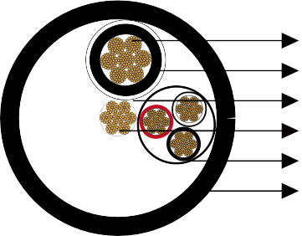





Stranded Tinned Copper Conductor EPR Insulation
Insulation Shield Grounding Conductor Control Group Reinforced CPE Jacket

Conductors:
Stranded annealed tinned copper conductor�

Insulation:
Ethylene Propylene Rubber (EPR)�

Insulation Shield:
Tinned copper/textile braid�

Control Group (3 Conductor):
Tinned copper conductor, EPR insulation and thermosetting jacket� Colour of insulation: Black, white and red�

www.caledonian-cables.co.uk www.addison-cables.com 29

Caledonian Mining Cables
Portable Power Cables

Grounding Conductor:
Tinned copper conductor, located in the center of the cable�

Jacket:
Reinforced extra-heavy-duty Chlorinated Polyethylene (CPE), black�

» Options .....................................................................................................................

- Other jacket materials such as CSP/PCP/NBR/PVC are available upon request�
- Two-layer jacket with reinforcing fibre between the two layers can be oﬀered as an option�

» Mechanical and Thermal Properties ......................................................................

Minimum Bending Radius: 6×OD
Maximum Conductor Operating Temperature: +90℃

» Dimensions and Weight
........................................................................................




Construction | No. of Strands | Grounding Conductor Size | Control Conductor Size | Nominal Insulation Thickness |  | Nominal Jacket Thickness |  | Nominal Overall Diameter |  | Nominal Weight |  | Ampacity
No. of cores×AWG/ kcmil | - | AWG/  kcmil | AWG/  kcmil | inch | mm | inch | mm | inch | mm | lbs/kft | kg/km | A
3×1/0 | 259 | 3 | 8 | 0�08 | 2�0 | 0�205 | 5�2 | 2�05 | 52�1 | 3092 | 4602 | 211
3×2/0 | 329 | 2 | 8 | 0�08 | 2�0 | 0�220 | 5�6 | 2�25 | 57�1 | 3698 | 5503 | 243
3×3/0 | 413 | 1 | 8 | 0�08 | 2�0 | 0�220 | 5�6 | 2�32 | 58�9 | 4295 | 6392 | 279
3×4/0 | 532 | 1/0 | 8 | 0�08 | 2�0 | 0�250 | 6�3 | 2�62 | 66�5 | 5115 | 7612 | 321
Ampacity-Based on a conductor temperature of 90℃ and an ambient air temperature of 40℃, per ICEA S-75-381�

30 www.caledonian-cables.co.uk www.addison-cables.com

