Caledonian Mining Cables
Portable Power Cables

Type SHD-CGC Three-Conductor Round Portable Power Cable 2kV

» Applications .............................................................................................................

These heavy duty cables are designed for applications such as longwall shearers, continuous miners, loaders, drills, conveyors, pumps, and other mobile equipment requiring grounding conductors, where a ground check conductor, and metallic shielding are required�

» Standards
................................................................................................................



ICEA S-75-381/NEMA WC 58 ASTM B 172
ASTM B 33
CAN/CSA C22�2 No� 96

» Construction ............................................................................................................

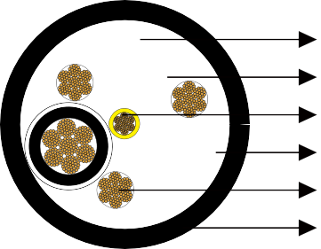





Stranded Tinned Copper Conductor

EPR Insulation

Ground Check Conductor

Insulation Shield

Grounding Conductor

Reinforced CPE Jacket

Conductors:
Stranded annealed tinned copper conductor�

Insulation:
Ethylene Propylene Rubber (EPR)�

Insulation Shield:
Tinned copper/textile braid�

Ground Check Conductor:
Tinned copper with a yellow insulation, located in the center of the cable�

www.caledonian-cables.co.uk www.addison-cables.com 33

Caledonian Mining Cables
Portable Power Cables
Grounding Conductor: Tinned copper conductor� Jacket:
Reinforced extra-heavy-duty Chlorinated Polyethylene (CPE), black�
» Options .....................................................................................................................
- Other jacket materials such as CSP/PCP/NBR/PVC are available upon request�
- Two-layer jacket with reinforcing fibre between the two layers can be oﬀered as an option�

» Mechanical and Thermal Properties ......................................................................

Minimum Bending Radius: 6×OD
Maximum Conductor Operating Temperature: +90℃

» Dimensions and Weight
........................................................................................




Construction | No. of Strands | Grounding Conductor Size | Ground Check Conductor Size | Nominal Insulation Thickness |  | Nominal Jacket Thickness |  | Nominal Overall Diameter |  | Nominal Weight |  | Ampacity
No. of cores×AWG/ kcmil | - | AWG/  kcmil | AWG/  kcmil | inch | mm | inch | mm | inch | mm | lbs/kft | kg/km | A
3×2/0 | 342 | 5 | 16 | 0�08 | 2�0 | 0�205 | 5�2 | 2�09 | 53�1 | 3400 | 5059 | 243
3×3/0 | 418 | 4 | 16 | 0�08 | 2�0 | 0�205 | 5�2 | 2�21 | 56�1 | 3934 | 5853 | 279
3×4/0 | 532 | 3 | 16 | 0�08 | 2�0 | 0�220 | 5�6 | 2�36 | 59�9 | 4860 | 7231 | 321
3×350 | 888 | 1 | 16 | 0�95 | 2�4 | 0�250 | 6�3 | 2�81 | 71�4 | 7400 | 11010 | 435
Ampacity-Based on a conductor temperature of 90℃ and an ambient air temperature of 40℃, per ICEA S-75-381�

34 www.caledonian-cables.co.uk www.addison-cables.com

