Caledonian Mining Cables
Portable Power Cables

Type SHD-CGC Three-Conductor Round Portable Power Cable 5kV

» Applications .............................................................................................................

These heavy duty cables are designed for applications such as longwall shearers, continuous miners, loaders, drills, conveyors, pumps, and other mobile equipment requiring grounding conductors, where a ground check conductor, and metallic shielding are required�

» Standards
................................................................................................................



ICEA S-75-381/NEMA WC 58 ASTM B 172
ASTM B 33
CAN/CSA C22�2 No� 96

» Construction ............................................................................................................

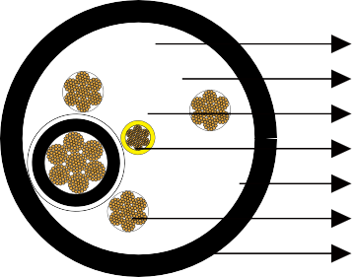





Stranded Tinned Copper Conductor Conductor Shield
EPR Insulation
Ground Check Conductor Insulation Shield Grounding Conductor Reinforced CPE Jacket

Conductors:
Stranded annealed tinned copper conductor�

Conductor Shield: Conducting layer� Insulation:
Ethylene Propylene Rubber (EPR)�

Insulation Shield:
Tinned copper/textile braid�

www.caledonian-cables.co.uk www.addison-cables.com 35

Caledonian Mining Cables
Portable Power Cables

Ground Check Conductor:
Tinned copper with a yellow insulation, located in the center of the cable�

Grounding Conductor: Tinned copper conductor� Jacket:
Reinforced extra-heavy-duty Chlorinated Polyethylene (CPE), black�

» Options .....................................................................................................................

- Other jacket materials such as CSP/PCP/NBR/PVC/TPU are available upon request�
- Two-layer jacket with reinforcing fibre between the two layers can be oﬀered as an option�

» Mechanical and Thermal Properties ......................................................................

Minimum Bending Radius: 6×OD
Maximum Conductor Operating Temperature: +90℃

» Dimensions and Weight
........................................................................................




Construction | No. of Strands | Grounding Conductor Size | Ground Check Conductor Size | Nominal Insulation Thickness |  | Nominal Jacket Thickness |  | Nominal Overall Diameter |  | Nominal Weight |  | Ampacity
No. of cores×AWG/ kcmil | - | AWG/  kcmil | AWG/  kcmil | inch | mm | inch | mm | inch | mm | lbs/kft | kg/km | A
3×2/0 | 323 | 5 | 16 | 0�11 | 2�8 | 0�220 | 5�6 | 2�20 | 55�9 | 3716 | 5529 | 243
3×3/0 | 418 | 4 | 16 | 0�11 | 2�8 | 0�235 | 6�0 | 2�36 | 59�9 | 4130 | 6145 | 279
3×4/0 | 532 | 3 | 16 | 0�11 | 2�8 | 0�235 | 6�0 | 2�50 | 63�5 | 5190 | 7722 | 321
3×350 | 888 | 1 | 16 | 0�12 | 3�0 | 0�265 | 6�7 | 2�95 | 74�9 | 7571 | 11264 | 435
Ampacity-Based on a conductor temperature of 90℃ and an ambient air temperature of 40℃, per ICEA S-75-381�

36 www.caledonian-cables.co.uk www.addison-cables.com

