Caledonian Mining Cables
Portable Power Cables

Type SHD-GC Three-Conductor Round Portable Power Cable, TPU Jacket 2kV

» Applications .............................................................................................................

These heavy duty cables are designed for heavy mobile equipment such as drag lines, shovels, dredges, drills and for power feeders�

» Standards
................................................................................................................



ICEA S-75-381/NEMA WC 58 ASTM B 172
ASTM B 33
CAN/CSA C22�2 No� 96

» Construction ............................................................................................................

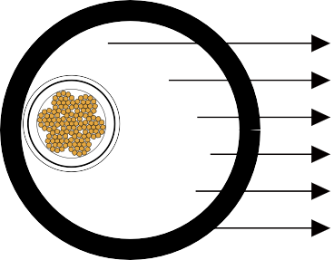




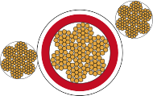

Ground Check Conductor

Stranded Tinned Copper Conductor EPR Insulation
Grounding Conductor Insulation Shield TPU Jacket

Conductors:
Stranded annealed tinned copper conductor�

Insulation:
Ethylene Propylene Rubber (EPR)�

Insulation Shield:
Tinned copper/textile braid�

Ground Check Conductor:
Tinned copper conductor with a yellow polypropylene insulation�

www.caledonian-cables.co.uk www.addison-cables.com 39

Caledonian Mining Cables
Portable Power Cables
Grounding Conductor: Tinned copper conductor� Jacket:
Thermoplastic Polyurethane (TPU) Jacket, black�
» Options .....................................................................................................................
- Other jacket materials such as CPE/CSP/PCP/NBR/PVC are available upon request�
- Two-layer jacket with reinforcing fibre between the two layers can be oﬀered as an option�

» Mechanical and Thermal Properties ......................................................................

Minimum Bending Radius: 6×OD
Maximum Conductor Operating Temperature: +90℃

» Dimensions and Weight
........................................................................................




Construction | No. of Strands | Grounding Conductor Size | Ground Check Conductor Size | Nominal Insulation Thickness |  | Nominal Jacket Thickness |  | Nominal Overall Diameter |  | Nominal Weight |  | Ampacity
No. of cores×AWG/ kcmil | - | AWG/  kcmil | AWG/  kcmil | inch | mm | inch | mm | inch | mm | lbs/kft | kg/km | A
3×6 | 133 | 10 | 10 | 0�07 | 1�8 | 0�155 | 3�9 | 1�29 | 32�8 | 1069 | 1590 | 93
3×4 | 259 | 8 | 10 | 0�07 | 1�8 | 0�155 | 3�9 | 1�40 | 35�6 | 1295 | 1927 | 122
3×2 | 259 | 6 | 10 | 0�07 | 1�8 | 0�170 | 4�3 | 1�59 | 40�4 | 1778 | 2645 | 159
3×1 | 259 | 5 | 8 | 0�08 | 2�0 | 0�190 | 4�8 | 1�76 | 44�7 | 2163 | 3218 | 184
3×1/0 | 266 | 4 | 8 | 0�08 | 2�0 | 0�190 | 4�8 | 1�86 | 47�2 | 2508 | 3731 | 211
3×2/0 | 323 | 3 | 8 | 0�08 | 2�0 | 0�205 | 5�2 | 2�00 | 50�8 | 3001 | 4465 | 243
3×3/0 | 418 | 2 | 8 | 0�08 | 2�0 | 0�205 | 5�2 | 2�13 | 54�1 | 3470 | 5163 | 279
3×4/0 | 532 | 1 | 8 | 0�08 | 2�0 | 0�220 | 5�6 | 2�31 | 58�7 | 4192 | 6237 | 321
3×250 | 627 | 1/0 | 6 | 0�095 | 2�4 | 0�220 | 5�6 | 2�51 | 63�8 | 5213 | 7756 | 355
3×350 | 888 | 2/0 | 6 | 0�095 | 2�4 | 0�235 | 6�0 | 2�81 | 71�4 | 6824 | 10153 | 435
3×500 | 1221 | 4/0 | 6 | 0�095 | 2�4 | 0�265 | 6�7 | 3�19 | 81�0 | 9014 | 13411 | 536
Ampacity-Based on a conductor temperature of 90℃ and an ambient air temperature of 40℃, per ICEA S-75-381�

40 www.caledonian-cables.co.uk www.addison-cables.com

