Caledonian Mining Cables
Portable Power Cables

Type SHD-GC Three-Conductor Round Portable Power Cable, TPU Jacket 8kV

» Applications .............................................................................................................

These heavy duty cables are designed for heavy mobile equipment such as drag lines, shovels, dredges, drills and for power feeders�

» Standards
................................................................................................................



ICEA S-75-381/NEMA WC 58 ASTM B 172
ASTM B 33
CAN/CSA C22�2 No� 96

» Construction ............................................................................................................

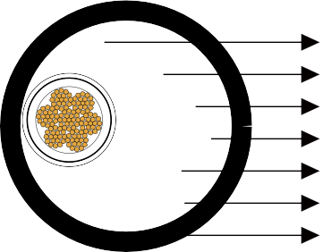




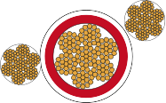

Ground Check Conductor
Stranded Tinned Copper Conductor Conductor Shield
Grounding Conductor EPR Insulation Insulation Shield TPU Jacket

Conductors:
Stranded annealed tinned copper conductor�

Conductor Shield: Conducting layer� Insulation:
Ethylene Propylene Rubber (EPR)�

Insulation Shield:
Conducting tape + Tinned copper/textile braid�

Ground Check Conductor:

www.caledonian-cables.co.uk www.addison-cables.com 47

Caledonian Mining Cables
Portable Power Cables

Tinned copper conductor with a yellow polypropylene insulation�

Grounding Conductor: Tinned copper conductor� Jacket:
Thermoplastic Polyurethane (TPU) Jacket, black�

» Options .....................................................................................................................

- Other jacket materials such as CPE/CSP/PCP/NBR/PVC are available upon request�
- Two-layer jacket with reinforcing fibre between the two layers can be oﬀered as an option�

» Mechanical and Thermal Properties ......................................................................

Minimum Bending Radius: 8×OD
Maximum Conductor Operating Temperature: +90℃

» Dimensions and Weight
........................................................................................




Construction | No. of Strands | Grounding Conductor Size | Ground Check Conductor Size | Nominal Insulation Thickness |  | Nominal Jacket Thickness |  | Nominal Overall Diameter |  | Nominal Weight |  | Ampacity
No. of cores×AWG/ kcmil | - | AWG/  kcmil | AWG/  kcmil | inch | mm | inch | mm | inch | mm | lbs/kft | kg/km | A
3×4 | 259 | 8 | 8 | 0�150 | 3�8 | 0�205 | 5�2 | 1�94 | 49�3 | 2019 | 3004 | 122
3×2 | 259 | 6 | 8 | 0�150 | 3�8 | 0�220 | 5�6 | 2�12 | 53�8 | 2603 | 3873 | 159
3×1 | 259 | 5 | 8 | 0�150 | 3�8 | 0�220 | 5�6 | 2�21 | 56�1 | 2913 | 4334 | 184
3×1/0 | 266 | 4 | 8 | 0�150 | 3�8 | 0�220 | 5�6 | 2�32 | 58�9 | 3351 | 4986 | 211
3×2/0 | 323 | 3 | 8 | 0�150 | 3�8 | 0�235 | 6�0 | 2�46 | 62�5 | 3946 | 5871 | 243
3×3/0 | 418 | 2 | 8 | 0�150 | 3�8 | 0�250 | 6�4 | 2�62 | 66�5 | 4582 | 6817 | 279
3×4/0 | 532 | 1 | 8 | 0�150 | 3�8 | 0�250 | 6�4 | 2�75 | 69�8 | 5321 | 7917 | 321
3×250 | 627 | 1/0 | 6 | 0�150 | 3�8 | 0�250 | 6�4 | 2�89 | 73�4 | 6101 | 9077 | 355
3×350 | 888 | 2/0 | 6 | 0�150 | 3�8 | 0�280 | 7�1 | 3�21 | 81�3 | 7696 | 11450 | 435
3×500 | 1221 | 4/0 | 6 | 0�150 | 3�8 | 0�295 | 7�5 | 3�56 | 90�4 | 10199 | 15174 | 536
Ampacity-Based on a conductor temperature of 90℃ and an ambient air temperature of 40℃, per ICEA S-75-381�

48 www.caledonian-cables.co.uk www.addison-cables.com

