Caledonian Mining Cables
Portable Power Cables

Type SHD-GC Three-Conductor

Round Portable Power Cable, CPE Jacket 15kV

» Applications .............................................................................................................

These heavy duty cables are designed for applications such as longwall shearers, continuous miners and mobile equipment such as shovels, dredges and drills�

» Standards
................................................................................................................



ICEA S-75-381/NEMA WC 58 ASTM B 172
ASTM B 33
CAN/CSA-C22�2 No�96

» Construction ............................................................................................................

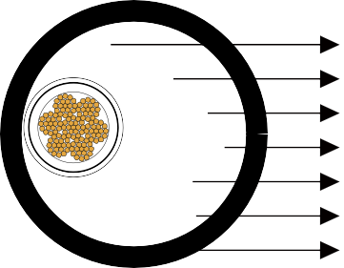




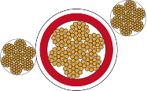

Ground Check Conductor
Stranded Tinned Copper Conductor Conductor Shield
Grounding Conductor EPR Insulation Insulation Shield Reinforced CPE Jacket

Conductors:
Stranded annealed tinned copper conductor�

Conductor Shield: Conducting layer� Insulation:
Ethylene Propylene Rubber (EPR)�

Insulation Shield:
Conducting tape + Tinned copper/textile braid�

www.caledonian-cables.co.uk www.addison-cables.com 49

Caledonian Mining Cables
Portable Power Cables

Ground Check Conductor:
Tinned copper with a yellow polypropylene insulation�

Grounding Conductor: Tinned copper conductor� Jacket:
Reinforced extra-heavy-duty Chlorinated Polyethylene (CPE), black�

» Options .....................................................................................................................

- Other jacket materials such as CSP/PCP/NBR/PVC/TPU are available upon request�
- Two-layer jacket with reinforcing fibre between the two layers can be oﬀered as an option�

» Mechanical and Thermal Properties ......................................................................

Minimum Bending Radius: 8×OD
Maximum Conductor Operating Temperature: +90℃

» Dimensions and Weight
........................................................................................




Construction | No. of Strands | Grounding Conductor Size | Ground Check Conductor Size | Nominal Insulation Thickness |  | Nominal Jacket Thickness |  | Nominal Overall Diameter |  | Nominal Weight |  | Ampacity
No. of cores×AWG/ kcmil | - | AWG/  kcmil | AWG/  kcmil | inch | mm | inch | mm | inch | mm | lbs/kft | kg/km | A
3×2 | 259 | 6 | 8 | 0�210 | 5�3 | 0�235 | 6�0 | 2�41 | 61�2 | 3572 | 5529 | 164
3×1 | 259 | 5 | 8 | 0�210 | 5�3 | 0�235 | 6�0 | 2�52 | 64�0 | 4060 | 6042 | 187
3×1/0 | 259 | 4 | 8 | 0�210 | 5�3 | 0�250 | 6�4 | 2�64 | 67�0 | 4495 | 6927 | 215
3×2/0 | 329 | 3 | 8 | 0�210 | 5�3 | 0�250 | 6�4 | 2�73 | 69�3 | 5010 | 7783 | 246
3×3/0 | 413 | 2 | 8 | 0�210 | 5�3 | 0�265 | 6�7 | 2�90 | 73�7 | 5995 | 8922 | 283
3×4/0 | 532 | 1 | 8 | 0�210 | 5�3 | 0�265 | 6�7 | 3�05 | 77�5 | 6860 | 10209 | 325
Ampacity-Based on a conductor temperature of 90℃ and an ambient air temperature of 40℃, per ICEA S-75-381�

50 www.caledonian-cables.co.uk www.addison-cables.com

