Caledonian Mining Cables
Portable Power Cables

Type SHD-GC Three-Conductor

Round Portable Power Cable, TPU Jacket 25kV

» Applications .............................................................................................................

These heavy duty cables are designed for heavy mobile equipment such as drag lines, shovels, dredges, drills and for power feeders�

» Standards
................................................................................................................



ICEA S-75-381/NEMA WC 58 ASTM B 172
ASTM B 33
CAN/CSA C22�2 No� 96

» Construction ............................................................................................................

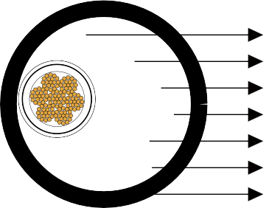




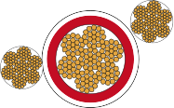

Ground Check Conductor
Stranded Tinned Copper Conductor Conductor Shield
Grounding Conductor EPR Insulation Insulation Shield TPU Jacket

Conductors:
Stranded annealed tinned copper conductor�

Conductor Shield: Conducting layer� Insulation:
Ethylene Propylene Rubber (EPR)�

Insulation Shield:
Conducting tape + Tinned copper/textile braid�

www.caledonian-cables.co.uk www.addison-cables.com 55

Caledonian Mining Cables
Portable Power Cables

Ground Check Conductor:
Tinned copper conductor with a yellow polypropylene insulation�

Grounding Conductor: Tinned copper conductor� Jacket:
Thermoplastic Polyurethane (TPU) Jacket, black�

» Options .....................................................................................................................

- Other jacket materials such as CPE/CSP/PCP/NBR/PVC are available upon request�
- Two-layer jacket with reinforcing fibre between the two layers can be oﬀered as an option�

» Mechanical and Thermal Properties ......................................................................

Minimum Bending Radius: 8×OD
Maximum Conductor Operating Temperature: +90℃

» Dimensions and Weight
........................................................................................





Caledonian Mining Cables
Portable Welding Cables

56 www.caledonian-cables.co.uk www.addison-cables.com

Construction | No. of Strands | Grounding Conductor Size | Ground Check Conductor Size | Nominal Insulation Thickness |  | Nominal Jacket Thickness |  | Nominal Overall Diameter |  | Nominal Weight |  | Ampacity
No. of cores×AWG/ kcmil | - | AWG/  kcmil | AWG/  kcmil | inch | mm | inch | mm | inch | mm | lbs/kft | kg/km | A
3×1 | 259 | 5 | 8 | 0�260 | 6�6 | 0�265 | 6�7 | 2�95 | 74�9 | 4410 | 6561 | 191
3×1/0 | 266 | 4 | 8 | 0�260 | 6�6 | 0�265 | 6�7 | 3�05 | 77�5 | 4866 | 7240 | 218
3×2/0 | 323 | 3 | 8 | 0�260 | 6�6 | 0�280 | 7�1 | 3�20 | 81�3 | 5560 | 8272 | 249
3×3/0 | 418 | 2 | 8 | 0�260 | 6�6 | 0�280 | 7�1 | 3�33 | 84�6 | 6192 | 9213 | 286
3×4/0 | 532 | 1 | 8 | 0�260 | 6�6 | 0�295 | 7�5 | 3�50 | 88�9 | 7110 | 10578 | 327
Ampacity-Based on a conductor temperature of 90℃ and an ambient air temperature of 40℃, per ICEA S-75-381�

56 www.caledonian-cables.co.uk www.addison-cables.com

