

Caledonian Mining Cables
Portable Power Cables

Type W Two-Conductor Round Portable Power Cable 2kV

» Applications .............................................................................................................

These cables are designed for general use where bare grounding conductors are not required or desired�

» Standards .................................................................................................................

ICEA S-75-381/NEMA WC 58 ASTM B 172
ASTM B 33
CAN/CSA C22�2 No� 96

» Construction ............................................................................................................
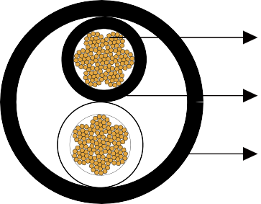

Stranded Tinned Copper Conductor

EPR Insulation

Reinforced CPE Jacket

Conductors:
Stranded annealed tinned copper conductor�

Insulation:
Ethylene Propylene Rubber (EPR)�

Jacket:
Reinforced heavy-duty/extra-heavy-duty Chlorinated Polyethylene (CPE), black� (Cables having a nominal outside diameter of more than 2�0 inches require extra-heavy-duty jackets�)

» Options .....................................................................................................................

- Other jacket materials such as CSP/PCP/NBR/PVC are available upon request�
- Two-layer jacket with reinforcing fibre between the two layers can be oﬀered as an option�

www.caledonian-cables.co.uk www.addison-cables.com 5



Caledonian Mining Cables
Portable Power Cables

» Mechanical and Thermal Properties ......................................................................

Minimum Bending Radius: 6×OD
Maximum Conductor Operating Temperature: +90℃

» Dimensions and Weight ..........................................................................................

Construction | No. of Strands | Nominal Insulation  Thickness |  | Nominal Jacket Thickness |  | Nominal Overall Diameter |  | Nominal Weight |  | Ampacity
No. of cores×AWG/ kcmil | - | inch | mm | inch | mm | inch | mm | lbs/kft | kg/km | A
2×8 | 166 | 0�06 | 1�5 | 0�110 | 2�8 | 0�83 | 21�1 | 391 | 581 | 72
2×6 | 259 | 0�06 | 1�5 | 0�125 | 3�2 | 0�94 | 23�9 | 571 | 849 | 95
2×4 | 412 | 0�06 | 1�5 | 0�140 | 3�6 | 1�07 | 27�3 | 793 | 1180 | 127
2×2 | 259 | 0�06 | 1�5 | 0�155 | 3�9 | 1�26 | 32�1 | 1142 | 1699 | 167
2×1/0 | 414 | 0�08 | 2�0 | 0�170 | 4�3 | 1�51 | 38�3 | 1693 | 2520 | 217
2×2/0 | 522 | 0�08 | 2�0 | 0�170 | 4�3 | 1�65 | 41�9 | 1908 | 2840 | 250
2×3/0 | 658 | 0�08 | 2�0 | 0�190 | 4�8 | 1�77 | 45�0 | 2600 | 3870 | 286
2×4/0 | 829 | 0�08 | 2�0 | 0�190 | 4�8 | 1�92 | 48�8 | 2675 | 3980 | 328
2×250 | 973 | 0�095 | 2�4 | 0�205 | 5�2 | 2�10 | 53�3 | 3434 | 5110 | 363
Ampacity-Based on a conductor temperature of 90℃ and an ambient air temperature of 40℃, per ICEA S-75-381�

6 www.caledonian-cables.co.uk www.addison-cables.com

