

Caledonian Mining Cables Cables for Underground Mining

NTSCGERLWOEU 3.6/6kV Flexible Submersible Cable

» Applications

These cables are used for permanent operation in water where the cable is required to have
additional mechanical protection.

» Standards

VDE 0250 Part 813

» Construction


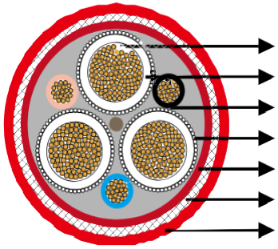
Stranded Copper Conductor 3GI3 Rubber Insulation Optional Pilot Cores
Earth Conductor
Synthetic Butyl Rubber Inner Sheath Galvanised Steel Wire Braid
5GM5 Rubber Outer Sheath

Conductors: Flexible stranded tinned copper conductor, class 5 according to DIN VDE 0295.
Inner Conductor Layer: Special rubber compound, conductive.
Insulation: Rubber type 3GI3.
Outer Conductor Layer: Special rubber, conductive, easy strippable.
Pilot Cores (optional): Copper conductor with EPR insulation. Earth Conductor: Spiral of tinned annealed copper wires. Inner Sheath: Waterproof synthetic butyl rubber.
Armouring: Braid of galvanised steel strands.
Outer Sheath: Rubber type 5GM5.

www.caledonian-cables.co.uk www.addison-cables.com 27



Caledonian Mining Cables
Cables for Underground Mining

» Dimensions and Weight

Number of Cores×Nominal Cross Section | Minimium Overall Diameter | Maximum Overall Diameter | Nominal Weight
No. ×mm² | mm | mm | kg/km
3×35+3×16/3E | 55�0 | 60�0 | 4600
3×50+3×25/3E | 59�0 | 67�0 | 5600
3×70+3×35/3E | 64�0 | 70�0 | 6700
3×95+3×50/3E | 68�0 | 75�0 | 7900
3×120+3×70/3E | 75�0 | 80�0 | 9980

28 www.caledonian-cables.co.uk www.addison-cables.com

