

Caledonian Mining Cables Cables for Underground Mining

NTSKCGERLOEU Medium Voltage Coal Cutter Cable

» Applications

These cables are used for the connection of mobile electrical equipment in underground mines,
e.g. for coal-cutting machines, especially for the use in bretby chains with extreme bending loads under low tensile stress.

» Standards

VDE 0250 Part 813

» Construction


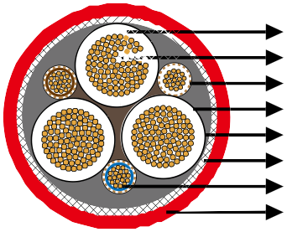
3GI3 Rubber Insulation
Stranded Tinned Copper Conductor Earth Conductor
Outer Conductor Layer
Semi Conductive+5GM5 Rubber Inner Sheath Spiral Of Copper And Steel Wires
Pilot Cores
5GM5 Rubber Outer Sheath

Conductors: Flexible stranded tinned copper conductor.
Insulation: Heat resistant 3GI3 rubber based on EPR.
Outer Conductor Layer (for 3.6/6kV): Easy strippable outer conductive layer.
Pilot Cores: Copper/steel conductor capable of expansion and compression with EPR rubber insulation.
Earth Conductor: Spiral of tinned copper wires and a conductive tape.
Inner Sheath: 2 layer design, semi conductive rubber + Rubber type 5GM5.
Armour: Spiral of steel wires, embedded in the outer sheath, fiberglas tape which prevents sheath
exchanging.
Outer Sheath: Rubber type 5GM5, abrasion and tear resistant, oil resistant and flame retardant.

www.caledonian-cables.co.uk www.addison-cables.com 29



Caledonian Mining Cables
Cables for Underground Mining

» Dimensions and Weight

1.8/3kV

Number of Cores×Nominal Cross Section | Minimium Overall Diameter | Maximum Overall Diameter | Nominal Weight
No. ×mm² | mm | mm | kg/km
3×35+3×(1.5ST+25/3)+UEL | 44�0 | 49�0 | 3900
3×50+3×(1.5ST+25/3)+UEL | 50�0 | 55�0 | 5100
3×70+3×(1.5ST+35/3)+UEL | 52�0 | 56�0 | 6200
3×95+3×(1.5ST+50/3)+UEL | 58�0 | 62�0 | 7500
3×120+3×(1.5ST+70/3)+UEL | 64�0 | 70�0 | 9350
3.6/6kV

Number of Cores×Nominal Cross Section | Minimium Overall Diameter | Maximum Overall Diameter | Nominal Weight
No. ×mm² | mm | mm | kg/km
3×35+3×(1.5ST+25/3)+UEL | 49�0 | 54�0 | 5800
3×50+3×(1.5ST+25/3)+UEL | 56�0 | 61�0 | 6100
3×70+3×(1.5ST+35/3)+UEL | 57�0 | 62�0 | 6700
3×95+3×(1.5ST+50/3)+UEL | 62�0 | 66�0 | 8000
3×120+3×(1.5ST+70/3)+UEL | 67�0 | 71�0 | 10200

30 www.caledonian-cables.co.uk www.addison-cables.com

