

Caledonian Mining Cables Cables for Underground Mining

NTSCGECWOEU Medium Voltage Coal Cutter Cable

» Applications

These cables are used for the connection of mobile electrical equipment in underground mines,
e.g. for coal-cutting machines, especially for the use in bretby chains with extreme bending loads under low tensile stress.

» Standards

VDE 0250 Part 813

» Construction


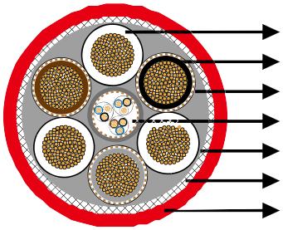
System1 System2
Earth Conductor Center Bundle
Semi Conductive+5GM5 Rubber Inner Sheath Spiral Of Steel Wires
5GM5 Rubber Outer Sheath

System1 (1.8/3kV or 3.6/6kV): Flexible stranded tinned copper conductor with heat resistant 3GI3 rubber based on EPR, easy strippable outer conductive layer.
System2 (0.6/1kV): Flexible stranded tinned copper conductor with heat resistant 3GI3 rubber based on EPR.
Earth Conductor: Spiral of tinned copper.
Center Bundle: Control and pilot cores with copper/steel conductors capable of expansion and compression, EPR insulation, optional with fiber optics, covered with tinned copper wires semi conductive rubber sheath.
Inner Sheath: 2 layer design, semi conductive rubber + Rubber type 5GM5.
Armour: Spiral of steel wires, embedded in the outer sheath, fiberglas tape which prevents sheath
exchanging.
Outer Sheath: Rubber type 5GM5, abrasion and tear resistant, oil resistant and flame retardant.

www.caledonian-cables.co.uk www.addison-cables.com 31



Caledonian Mining Cables
Cables for Underground Mining

» Dimensions and Weight

1.8/3kV

Number of Cores×Nominal Cross Section | Minimium Overall Diameter | Maximum Overall Diameter | Nominal Weight
No. ×mm² | mm | mm | kg/km
3×50+3×(35+35/3)+2×(2×0.75ST)+2×0.75UEL | 62�0 | 66�0 | 7210
3×70+3×(50+50/3)+2×(2×0.75ST)+2×0.75UEL | 64�0 | 68�0 | 8200
3×95+3×(70+70/3)+2×(2×0.75ST)+2×0.75UEL | 74�0 | 78�0 | 10300
3.6/6kV

Number of Cores×Nominal Cross Section | Minimium Overall Diameter | Maximum Overall Diameter | Nominal Weight
No. ×mm² | mm | mm | kg/km
3×35+3×(35+35/3)+2×(2×0.75ST)+2×0.75UEL | 66�0 | 72�0 | 7600
3×50+3×(50+50/3)+2×(2×0.75ST)+2×0.75UEL | 69�0 | 75�0 | 9200
3×70+3×(70+70/3)+2×(2×0.75ST)+2×0.75UEL | 76�0 | 81�0 | 11150
3×95+3×(95+95/3)+2×(2×0.75ST)+2×0.75UEL | 85�0 | 90�0 | 13300

32 www.caledonian-cables.co.uk www.addison-cables.com

