Caledonian Mining Cables Cables for Underground Mining

(N)TSCGECWOEU Medium Voltage Trailing Cable

» Applications

These cables are used for the connection of electrical equipment, in mines and underground excavations with hazardous environments under particularly high mechanical loads, e.g. high-voltage transformers on power lines in underground mining and tunnelling.

» Standards

Based on VDE 0250 Part 813

» Construction

Stranded Copper Conductor 3GI3 Rubber Insulation Optional Pilot Cores
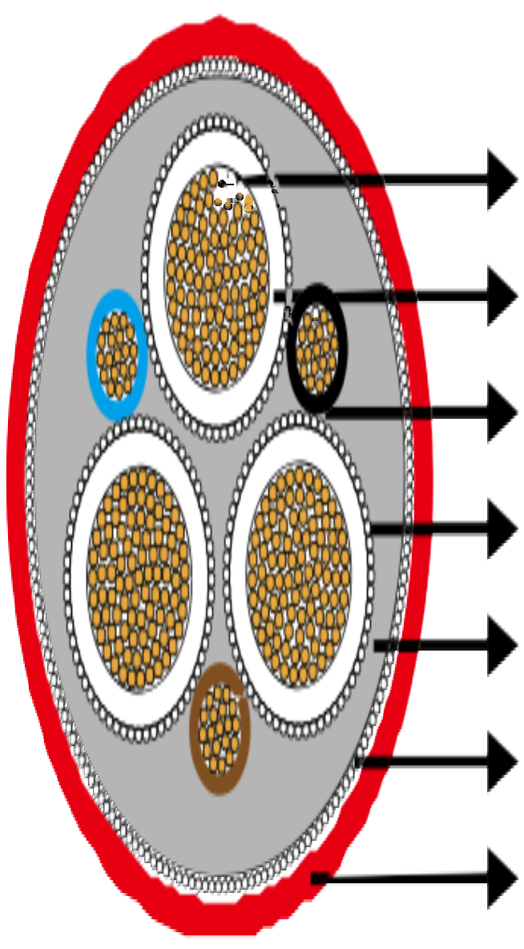

Earth Conductor GM1b Inner Sheath Monitoring Conductor
5GM5 Rubber Outer Sheath




Conductors: Flexible stranded copper conductor, class 5 according to DIN VDE 0295.
Inner Conductor Layer: Special rubber compound, conductive.
Insulation: Rubber type 3GI3.
Outer Conductor Layer: Special rubber compound, conductive, easy strippable.
Pilot Cores (optional): Tinned copper conductor with EPR insulation.
Earth Conductor: Spiral of tinned copper wires.
Inner Sheath: Rubber type GM1b.
Monitoring Shield/Armour: Braided armour of combined copper-steel wires; or wrap of copper and steel wires, copper tape in opposite direction, reinforcing tape.
Outer Sheath: Rubber type 5GM5.

www.caledonian-cables.co.uk www.addison-cables.com 33



Caledonian Mining Cables
Cables for Underground Mining

» Dimensions and Weight

6/10kV

Number of Cores×Nominal Cross Section | Minimium Overall Diameter | Maximum Overall Diameter | Nominal Weight
No. ×mm² | mm | mm | kg/km
3×25+3×16/3E+3×2�5ST+6UEL | 48�0 | 52�0 | 3500
3×35+3×16/3E+3×2�5ST+6UEL | 51�0 | 55�0 | 3750
3×50+3×25/3E+3×2�5ST+6UEL | 56�0 | 60�0 | 4720
3×95+3×50/3E+3×2�5ST+6UEL | 66�0 | 71�0 | 7260
3×120+3×70/3E+6UEL | 70�0 | 75�0 | 9700
3×150+3×70/3E+6UEL | 73�0 | 78�0 | 9950
12/20 (24) kV

Number of Cores×Nominal Cross Section | Minimium Overall Diameter | Maximum Overall Diameter | Nominal Weight
No. ×mm² | mm | mm | kg/km
3×25+3×25/3E+6UEL | 62�0 | 67�0 | 5800
3×95+3×50/3E+6UEL | 74�0 | 78�0 | 11000
3×120+3×70/3E+6UEL | 80�0 | 85�0 | 13000

34 www.caledonian-cables.co.uk www.addison-cables.com

