Caledonian Mining Cables Cables for Underground Mining

(N)TSCGEWOEU Medium Voltage Trailing Cable

With Anti-Torsion Braid

» Applications

These cables are used for the connection of electrical equipment, in mines and underground excavations with hazardous environments under particularly high mechanical loads, e.g. high-voltage transformers on power lines in underground mining and tunnelling.

» Standards

Based on VDE 0250 Part 813

» Construction

Conductors: Flexible stranded copper


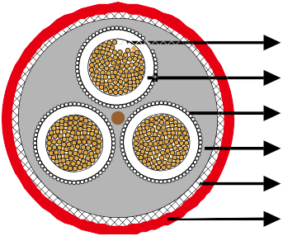
Stranded Copper Conductor 3GI3 Rubber Insulation Earth Conductor
GM1b Inner Sheath Polyester Anti-torsion Braid
5GM5 Rubber Outer Sheath



conductor, class 5 according to DIN VDE 0295.
Inner Conductor Layer: Special rubber compound, conductive.
Insulation: Rubber type 3GI3.
Outer Conductor Layer: Special rubber compound, conductive, easy strippable.
Earth Conductor: Spiral of tinned copper wires.
Inner Sheath: Rubber type GM1b.
Reinforcement: Polyester anti-torsion braid between the jackets embedded.
Outer Sheath: Rubber type 5GM5.

» Dimensions and Weight

8.7/15kV

Number of Cores×Nominal Cross Section | Minimium Overall Diameter | Maximum Overall Diameter | Nominal Weight
No. ×mm² | mm | mm | kg/km
3×150+3×70/3E | 73�0 | 78�0 | 10150

www.caledonian-cables.co.uk www.addison-cables.com 35

