Caledonian Mining Cables

Cables for Underground Mining

N3GHSSYCY Medium Voltage Cable

» Applications

These cables are used for the connection of mobile operating equipment, in mines and underground excavations with hazardous environments, in stationary operation, e.g. high-voltage transformers in mining and tunnelling.

» Standards

VDE 0250 Part 605

» Construction
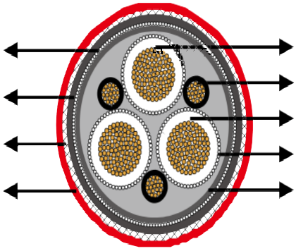

Monitoring Conductor PVC Intermediate Sheath Galvanized Steel Wires Braid 5GM5 Rubber Outer Sheath

Stranded Copper Conductor Pilot Cores
3GI3 Rubber Insulation Earth Conductor
PVC Inner Sheath




Conductors: Flexible stranded copper conductor, class 5 according to DIN VDE 0295.
Insulation: EPR compound type 3GI3.
Electrical Field Control: Inner and outer semiconductive layer of semiconductive rubber, for 6 kV outer semiconductive layer only.
Pilot Cores: Stranded copper conductor with EPR insulation.
Earth Conductor: Spiral of copper wires over the outer semi-conductive layer of the cores.
Inner Sheath: PVC compound type YM5.
Monitoring Conductor: Conductive tape serving and overall concentric Cu wire spinning.
Intermediate Sheath: PVC compound type YM5.
Armour: Braid of galvanized steel wires.
Outer Sheath: PVC compound type YM5.

38 www.caledonian-cables.co.uk www.addison-cables.com



Caledonian Mining Cables Cables for Underground Mining

» Dimensions and Weight

3.6/6kV

Number of Cores×Nominal Cross Section | Minimium Overall Diameter | Maximum Overall Diameter | Nominal Weight
No. ×mm² | mm | mm | kg/km
3×25+3×16/3E+3×2�5ST+UEL | 49�0 | 53�0 | 4190
3×35+3×16/3E+3×2�5ST+UEL | 52�0 | 56�0 | 4800
3×50+3×25/3E+3×2�5ST+UEL | 55�0 | 59�0 | 5600
3×70+3×35/3E+3×2�5ST+UEL | 59�0 | 63�0 | 6650
3×95+3×50/3E+3×2�5ST+UEL | 63�0 | 67�0 | 7940
6/10kV

Number of Cores×Nominal Cross Section | Minimium Overall  Diameter | Maximum Overall  Diameter | Nominal Weight
No. ×mm² | mm | mm | kg/km
3×25+3×16/3E+3×2�5ST+UEL | 55�0� | 58�0 | 5300
3×35+3×16/3E+3×2�5ST+UEL | 58�0 | 61�0 | 5910
3×50+3×25/3E+3×2�5ST+UEL | 61�0 | 65�0 | 6790
3×70+3×35/3E+3×2�5ST+UEL | 65�0 | 69�0 | 7860
3×95+3×50/3E+3×2�5ST+UEL | 68�0 | 73�0 | 9180
8.7/15kV

Number of Cores×Nominal Cross Section | Minimium Overall  Diameter | Maximum Overall  Diameter | Nominal Weight
No. ×mm² | mm | mm | kg/km
3×25+3×16/3E+3×2�5ST+UEL | 58�0 | 62�0 | 6810
3×35+3×16/3E+3×2�5ST+UEL | 61�0 | 65�0 | 7850
3×50+3×25/3E+3×2�5ST+UEL | 64�7 | 68�7 | 9130
3×70+3×35/3E+3×2�5ST+UEL | 67�9 | 71�9 | 10750
3×95+3×50/3E+3×2�5ST+UEL | 72�4 | 76�4 | 12290
12/20kV

Number of Cores×Nominal Cross Section | Minimium Overall Diameter | Maximum Overall Diameter | Nominal Weight
No. ×mm² | mm | mm | kg/km
3×25+3×16/3E+3×2�5ST+UEL | 62�3 | 66�3 | 8790
3×35+3×16/3E+3×2�5ST+UEL | 65�3 | 69�3 | 9930
3×50+3×25/3E+3×2�5ST+UEL | 69�0 | 73�0 | 11360
3×70+3×35/3E+3×2�5ST+UEL | 72�2 | 76�2 | 13100
3×95+3×50/3E+3×2�5ST+UEL | 76�8 | 80�8 | 14750

www.caledonian-cables.co.uk www.addison-cables.com 39

