

Caledonian Mining Cables Cables for Open-cast Mining

2YSLGCGOEU Signal & Control Cable

» Applications

These control, signalling and bus cables are used for electric and electronic equipment, such as for measured value and process data processing and automation units in open-cast mining applications, suitable for laying alongside conveyor belts and on material handling equipment.

» Standards

VDE 0250 Part 812

» Construction

Stranded Copper Conductor 2YI1 Insulation
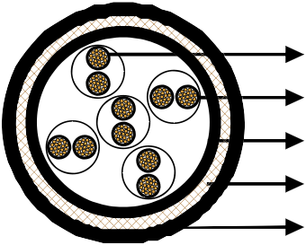

EM2 Inner Sheath
Tinned Copper Wire Braid EM2 Outer Sheath
Conductors: Flexible stranded copper conductor, class 5 according to DIN VDE 0295.
Insulation: PE type 2YI1.
Cable Element: Cores are laid-up in pairs in layers with a continuous serving of non-hygroscopic material over the conductor assembly
Inner Sheath: CM type EM2. Screen: Tinned copper wire braid. Outer Sheath: CM type EM2.

» Dimensions and Weight

Number of Cores×Nominal Cross Section | Minimium Overall Diameter | Maximum Overall Diameter | Nominal Weight
No. ×mm² | mm | mm | kg/km
2×2×1 | 11�0 | 13�0 | 245
5×2×1 | 16�0 | 19�0 | 440
10×2×1 | 20�0 | 23�0 | 700
20×2×1 | 25�0 | 29�0 | 1040

www.caledonian-cables.co.uk www.addison-cables.com 43

