Caledonian Mining Cables

Cables for Underground Mining

NTSWOEU 0.6/1kV E-Loader Cable

» Applications

These cables are used for the connection of mobile machines under extremely high mechanical loads, predominantly in mining situations, also can be operated via guide pulleys (cable cars) or used as a reeling cable (LHD), suitable for extreme bending loads, high tensile stress, and impact and crushing loads.

» Standards

VDE 0250 Part 813

» Construction
Stranded Tinned Copper Conductor Optional Special Pilot Cores

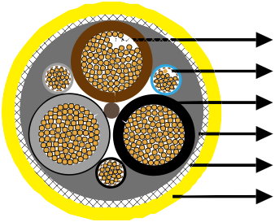
EPR Insulation
GM1b Rubber Inner Sheath Copper-Steel Wires Braid 5GM5 Rubber Outer Sheath



Conductors: Flexible stranded tinned copper conductor, class 6 according to DIN VDE 0295.
Insulation: EPR.
Pilot Cores (optional): Special conductor, tinned copper braid and galvanised steel wire braid.
Inner Sheath: Rubber type GM1b.
Armour/Earth Conductor: Concentric earth conductor as tensile-stress-resistant braided armour of combined copper-steel wires.
Outer Sheath: Chlorinated rubbe type 5GM5, abrasion and tear resistant, oil resistant and flame
retardant.

» Dimensions and Weight

Number of Cores×Nominal Cross Section | Insulation Thickness | Thickness of Inner Sheath | Thickness of Outer Sheath | Nominal Overall Diameter | Nominal Weight
No. ×mm² | mm | mm | mm | mm | kg/km
3x50/25KON + 3xST | 2�0 | 3�0 | 5�0 | 56 | 4950

12 www.caledonian-cables.co.uk www.addison-cables.com

