Caledonian Mining Cables

Cables for Underground Mining

NSHTOEU 0.6/1kV LHD Cables

» Applications

These cables are used for frequently changing dynamic loads, such as reeling cables for scoops
(LHDs) in underground mines, suitable for mono-spiral reels and cylindrical reels.

» Standards

VDE 0250 Part 814

» Construction

Conductors: Flexible stranded tinned

Stranded Tinned Copper Conductor 3GI3 Insulation
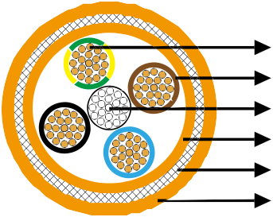

Steel Support Element 5GM5 Inner Sheath Polyester Threads Braid

copper conductor.
Insulation: EPR type 3GI3.
Support Element: Central steel support element.
Inner Sheath: PCP type 5GM5.
5GM5 Outer Sheath



Anti-torsion Braid: Reinforced braid of polyester threads in a vulcanized bond between inner and outer sheath.
Outer Sheath: PCP type 5GM5.

» Dimensions and Weight

Number of Cores×Nominal Cross Section | Minimum Overall Diameter | Maximum Overall Diameter | Nominal Weight
No. ×mm² | mm | mm | kg/km
4x16(6 kN) | 27�5 | 31�5 | 1500
4x35(12 kN) | 37�5 | 42�0 | 2920
4x50(12 kN) | 43�0 | 48�0 | 3970
4x50(30 kN) | 42�0 | 44�0 | 3660
4x70 (20kN) | 47�0 | 52�0 | 5530
4x95 (50kN) | 53�0 | 58�0 | 6500

14 www.caledonian-cables.co.uk www.addison-cables.com

