Caledonian Mining Cables Cables for Underground Mining

NSSHCGEOEU 0.6/1kV Coal Cutter Cable (High Tensile Stress)

» Applications

These cables are used for the connection of mobile machines under extremely high mechanical loads, predominantly in mining situations, e.g. for coal-cutting machines, also can be operated via guide pulleys (cable cars) or used as a reeling cable (LHD), suitable for extreme bending loads, high tensile stress, and impact and crushing loads.

» Standards

VDE 0250 Part 812

» Construction

Stranded Tinned Copper Conductor Monitoring Conductor
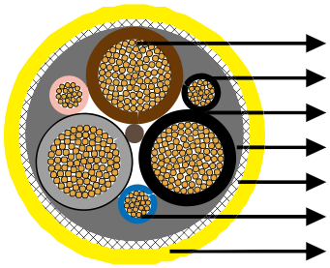

3GI3 Rubber Insulation GM1b Rubber Inner Sheath Copper-Steel Wires Braid Pilot Cores
5GM5 Rubber Outer Sheath



Conductors: Flexible stranded tinned copper conductor.
Insulation: Heat resistant 3GI3 rubber based on EPR.
Outer Conductor Layer: Easy strippable outer conductive layer.
Pilot Cores: Copper and steel conductor capable of expansion and compression with 3GI3 EPR rubber insulation.
Monitoring Conductor: Copper and steel conductor capable of expansion and compression covert with semi conductive rubber compound.
Inner Sheath: Rubber type GM1b.
Armour/Earth Conductor: Concentric earth conductor as tensile-stress-resistant braided armour of combined copper-steel wires.
Outer Sheath: Rubber type 5GM5, abrasion and tear resistant, oil resistant and flame retardant.

www.caledonian-cables.co.uk www.addison-cables.com 15



Caledonian Mining Cables
Cables for Underground Mining

» Dimensions and Weight

Number of Cores×Nominal Cross Section | Minimium Overall Diameter | Maximum Overall Diameter | Nominal Weight
No. ×mm² | mm | mm | kg/km
3×16/16KON+2ST+UEL | 38�5 | 41�5 | 2430
3×25/16KON+2ST+UEL | 41�0 | 44�5 | 3050
3×35/16KON+2ST+UEL | 44�5 | 48�0 | 3620
3×50/25KON+2ST+UEL | 50�0 | 54�0 | 4810
3×70/35KON+2ST+UEL | 54�5 | 58�5 | 5890
3×95/50KON+2ST+UEL | 62�5 | 66�5 | 7800
3×35/16KON+3ST+3UEL | 44�5 | 48�0 | 3860
3×50/25KON+3ST+3UEL | 50�0 | 54�0 | 5050
3×70/35KON+3ST+3UEL | 54�5 | 58�5 | 6000
3×95/50KON+3ST+3UEL | 62�5 | 66�5 | 8050
3×120/70KON+3ST+3UEL | 67�5 | 72�0 | 9380
3×150/70KON+3ST+3UEL | 74�5 | 79�0 | 11120

16 www.caledonian-cables.co.uk www.addison-cables.com

