

Caledonian Mining Cables Cables for Underground Mining

NSSHCGEOEU 0.6/1kV Coal Cutter Cable (Low Tensile Stress)

» Applications

These cables are used for the connection of mobile machines under extremely high mechanical loads, predominantly in mining situations, e.g. for coal-cutting machines, suitable for extreme bending loads under low tensile stress.

» Standards

DIN VDE 0250 Part 812

» Construction

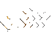


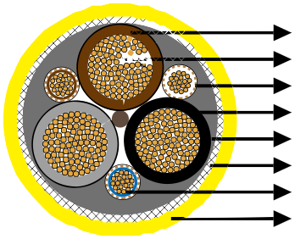
3GI3 Rubber Insulation
Stranded Tinned Copper Conductor Monitoring Conductor
Outer Conductor Layer
GM1b Rubber Inner Sheath Spiral Of Copper And Steel Wires Pilot Cores
5GM5 Rubber Outer Sheath

Conductors: Flexible stranded tinned copper conductor.
Insulation: Heat resistant 3GI3 rubber based on EPR.
Outer Conductor Layer: Easy strippable outer conductive layer.
Pilot Cores: Copper strand and steel braid conductor capable of expansion and compression with EPR rubber insulation.
Monitoring Cores: Spiral of tinned copper wires above the pilot cores, covered with a semi- conductive tape.
Inner Sheath: Rubber type GM1b.
Armour/Earth Conductor: Concentric earth conductor as spiral of copper and steel wires,
fibreglas tape, embedded in the outer sheath which prevents sheath exchanging.
Outer Sheath: Rubber type 5GM5, abrasion and tear resistant, oil resistant and flame retardant.

www.caledonian-cables.co.uk www.addison-cables.com 17



Caledonian Mining Cables
Cables for Underground Mining

» Dimensions and Weight

Number of Cores×Nominal Cross Section | Minimium Overall Diameter | Maximum Overall Diameter | Nominal Weight
No. ×mm² | mm | mm | kg/km
3×16/16KON+2ST+UEL | 35�0 | 38�0 | 2130
3×25/16KON+2ST+UEL | 38�0 | 41�0 | 2790
3×35/16KON+2ST+UEL | 41�0 | 45�0 | 3390
3×50/25KON+2ST+UEL | 47�0 | 51�0 | 4340
3×70/35KON+2ST+UEL | 52�0 | 56�0 | 5680
3×95/50KON+2ST+UEL | 58�0 | 62�0 | 7180
3×25/16KON+3×(1.5ST+UEL) | 38�0 | 41�0 | 2920
3×35/16KON+3×(1.5ST+UEL) | 41�0 | 45�0 | 3630
3×50/25KON+3×(1.5ST+UEL) | 45�0 | 48�0 | 4500
3×70/35KON+3×(1.5ST+UEL) | 48�0 | 53�0 | 5850
3×95/50KON+3×(1.5ST+UEL) | 52�0 | 56�0 | 7400
3×120/70KON+3×(1.5ST+UEL) | 58�0 | 63�0 | 8300
3×150/70KON+3×(1.5ST+UEL) | 62�0 | 68�0 | 9300

18 www.caledonian-cables.co.uk www.addison-cables.com

