Caledonian Mining Cables Cables for Underground Mining

(N)SSHOEU 0.6/1kV Heavy Duty Flexible Cable

» Applications

These cables are used for connection of mobile equipment and machines under very high mechanical loads in dry and damp areas, outdoors and in explosion hazard areas, particularly in mining and at quarries and building sites.

» Standards

Based on VDE 0250 Part 812

» Construction

Stranded Tinned Copper Conductor 3GI3 Rubber Insulation
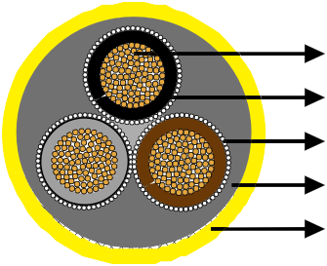

Earth Conductor

GM1b Rubber Inner Sheath 5GM5 Rubber Outer Sheath



Conductors: Flexible stranded copper conductor, class 5 according to DIN VDE 0295.
Insulation: Rubber type 3GI3.
Pilot Cores (optional): Tinned copper conductor with EPR insulation.
Earth Conductor: Spiral of tinned copper wires.
Inner Sheath: Rubber type GM1b.
Outer Sheath: Rubber type 5GM5.

» Dimensions and Weight

Number of Cores×Nominal Cross Section | Minimium Overall Diameter | Maximum Overall Diameter | Nominal Weight
No. ×mm² | mm | mm | kg/km
3x2.5+3x2.5/3E | 14�0 | 17�0 | 300
3x6+3x6/3E | 18�0 | 21�0 | 580
3x10+3x10/3E | 21�0 | 25�0 | 860

www.caledonian-cables.co.uk www.addison-cables.com 19

